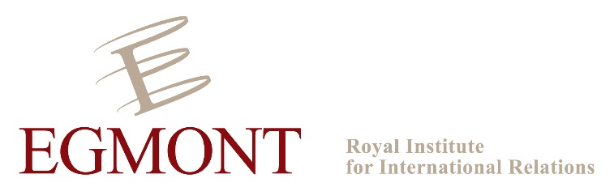

Strategic Debates in the EU and China: A Discussion
Thursday 5 November, 15:00 – 17:30
Egmont Institute’s meeting room, 24a rue des petits carmes, 1000 Brussels

The Egmont Institute organises a small roundtable to discuss key strategic issues in the EU and China. This roundtable aims to bring together some Chinese and European scholars, in order to share their views and ideas. A delegation of the Shanghai Academy of Social Sciences (SIIS) will participate. Each session will start with very short presentations (from a European and Chinese scholars) before opening to an open discussion, under the Chatham House Rule.

15:00 Welcome

15:15 – 16:15 Topic 1
Strategic debates and ‘hot spots’ in the EU and China
What are the key topics driving strategic and foreign policy discussions these days in Europe and in China? What are the key strategic and foreign policy priorities? What are the common interests and possible areas for cooperation?

16:15 – 16:30 Break

16:30 – 17:30 Topic 2:
Strategic investment projects in the EU and China: the Juncker Plan and the One Belt, One Road
What is the Juncker Plan, and the rationale behind it? What is China’s One Belt, One Road strategy, and what is its purpose? How are these projects serving the EU and China’s strategic objectives? Are these projects compatible, and is cooperation possible?

17:30 End

